Project 2



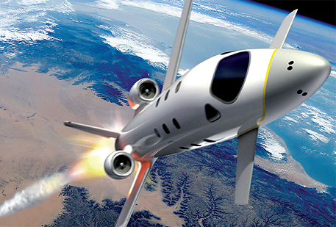

**FDIR**

*Spacecraft fault protection system*

**Euro Team**

|  |  |
| --- | --- |
| **Mikko AHVENNIEMI** | 20096680 |
| **Pierre ALAUZET** | 20096699 |
| **Julien COLIN** | 20096706 |
| **Benoît STARCK** | 20096705 |

**Table of contents**

December 12th, 2009

**CS554 - Design for Software & Systems**

Illustration table 3

Introduction 4

1. ACME, a powerful ADL 5

2. Utility tree 6

3. Architecture 7

4. Architectural approach analysis 8

5. Discussions & alternatives 9

Conclusion 10

References 11

Annexes 12

1. 12

**Illustration table**

Aucune entrée de table d'illustration n'a été trouvée.

**Introduction**

In the purpose of applying and studying real case project for the *Design for Softwares and Systems* course, our team is required to understand and design a fault protection system for a spacecraft as described in the article by Steve Easterbrook et al. [Eas98]. The first part of this global project is to understand the problems we have to respond, to specify the needs of our client and to start thinking about a user system interface.

1. **System description & business case**

1. **Utility tree**
2. **Architecture**
3. **Architectural approach analysis**
4. **Discussions & alternatives**

**Conclusion**

**References**

**Web Sites**

**Books**

**Annexes**